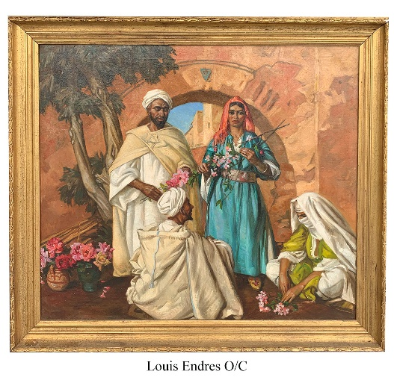**BURCHARD GALLERIES AUCTIONS**

**2 BIG September Auction Events**

**September 21st / 22nd**

**Over 1000+ Items from more than 20 Estates. Huge Fine Art Collection in this upcoming Auction, Vintage Period Antiques, Stunning Estate Diamonds, Gold & Silver!**

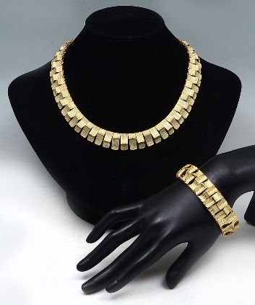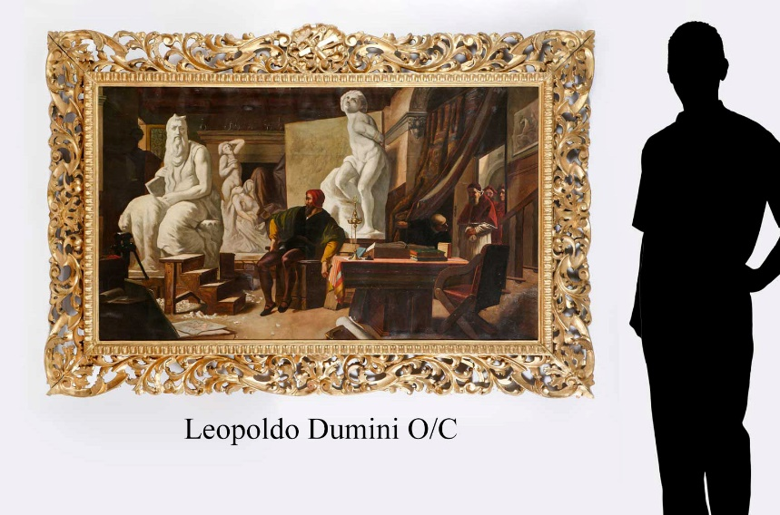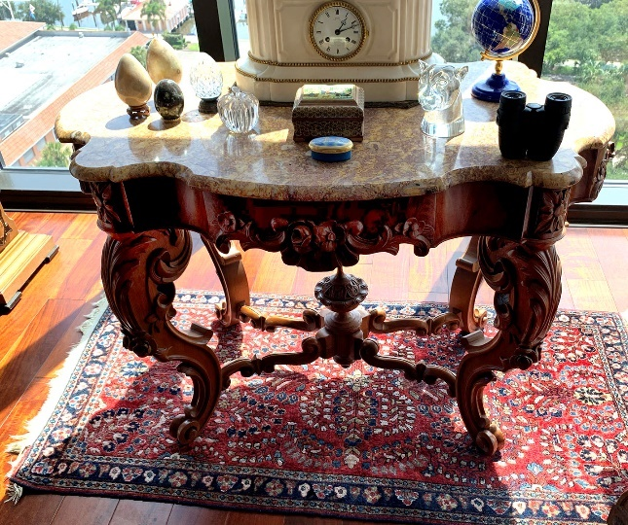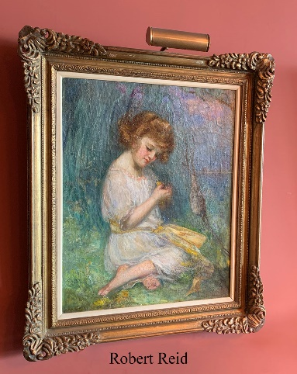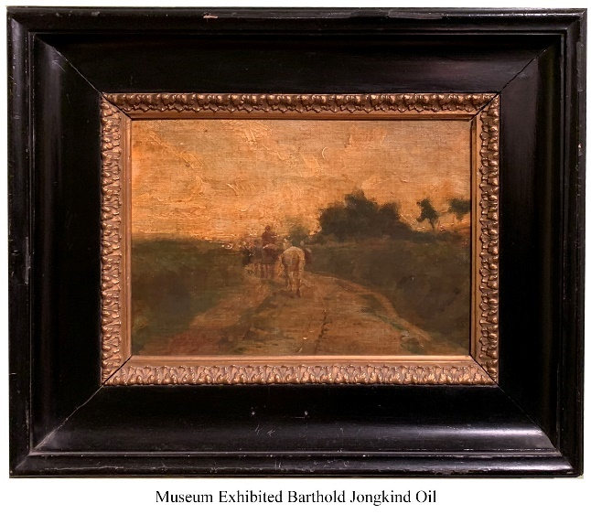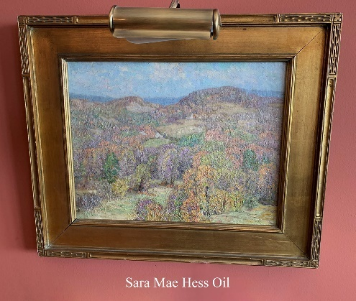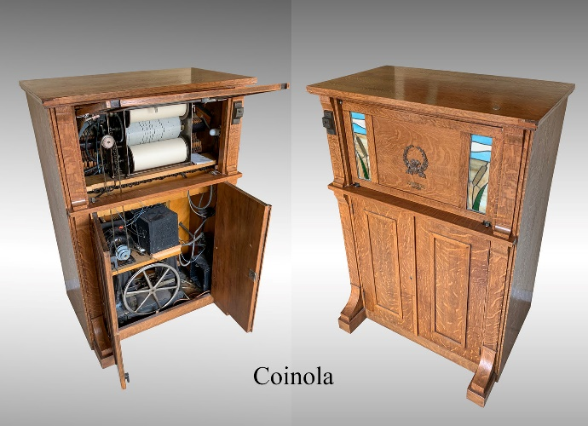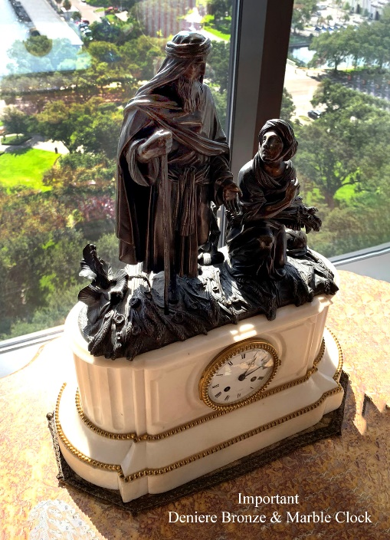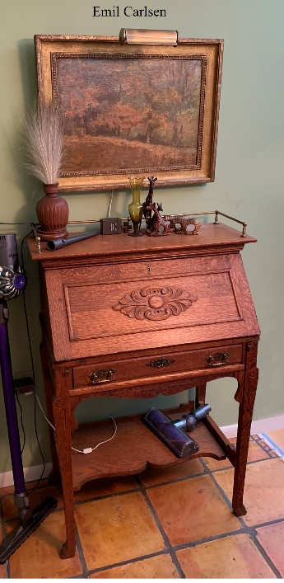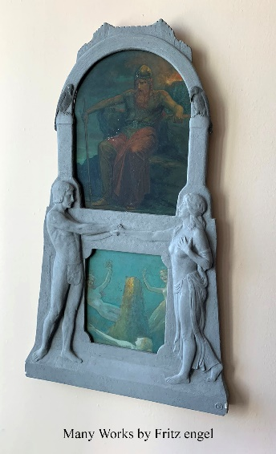**Come be a part of the Action! Consignments Welcome.**

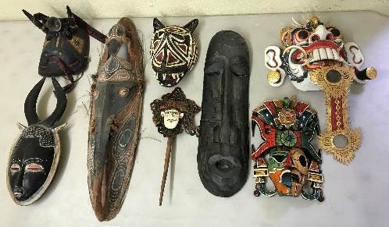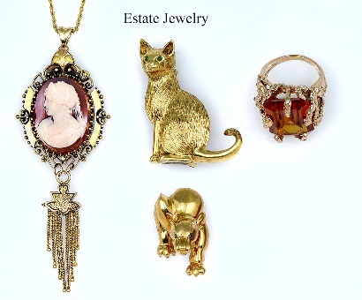

[**www.BurchardGalleries.com**](http://www.BurchardGalleries.com)

[**mail@BurchardGalleries.com**](mailto:mail@BurchardGalleries.com) **727-821-1167**